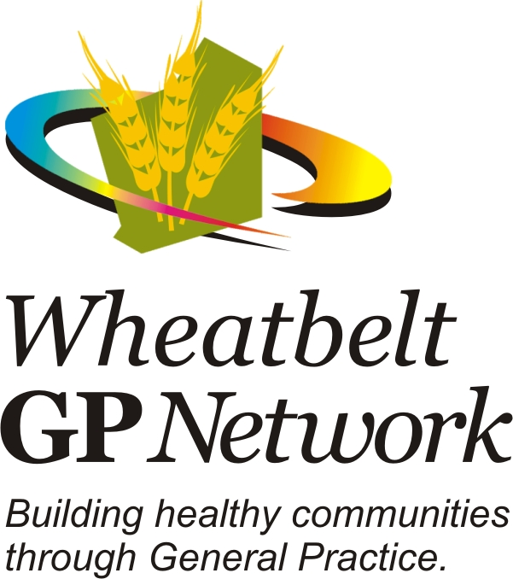
CPD Portfolio for:___________________
Learning Needs Plan Examples:

- Update wound management knowledge to improve patient outcomes
- Increase knowledge about diabetes management
- Improve IT skills to assist with the completion of health assessments
- Expand scope of practice for ear syringing
- Cultural awareness
- CPR update

Date | Learning need | Activity | Evaluation/Reflection | CPD Hours

